**Problem 1**

1. state.x77 dataset has 50 observations on 8 variables. There is no respond variable and all variables are considered as predictor variables. All the variables are quantitative. Bellow is a summary of these variables.

Population Income Illiteracy Life Exp Murder HS Grad

Min. : 365 Min. :3098 Min. :0.500 Min. :67.96 Min. : 1.400 Min. :37.80

1st Qu.: 1080 1st Qu.:3993 1st Qu.:0.625 1st Qu.:70.12 1st Qu.: 4.350 1st Qu.:48.05

Median : 2838 Median :4519 Median :0.950 Median :70.67 Median : 6.850 Median :53.25

Mean : 4246 Mean :4436 Mean :1.170 Mean :70.88 Mean : 7.378 Mean :53.11

3rd Qu.: 4968 3rd Qu.:4814 3rd Qu.:1.575 3rd Qu.:71.89 3rd Qu.:10.675 3rd Qu.:59.15

Max. :21198 Max. :6315 Max. :2.800 Max. :73.60 Max. :15.100 Max. :67.30

Frost Area

Min. : 0.00 Min. : 1049

1st Qu.: 66.25 1st Qu.: 36985

Median :114.50 Median : 54277

Mean :104.46 Mean : 70736

3rd Qu.:139.75 3rd Qu.: 81163

Max. :188.00 Max. :566432

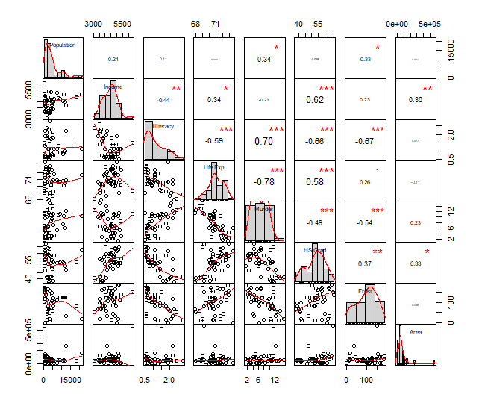Following figure shows how most of these variables, specially Life Exp, Murder, HS Grad and Frost, are highly correlates with other variables.

1. Data needs to be standardized in order to make the sample mean of principle components = 0 and variance equal to the eigen values of them. Thus make them uncorrelated.

> apply(state.x77, 2, mean)

Population Income Illiteracy Life Exp Murder HS Grad Frost Area

4246.4200 4435.8000 1.1700 70.8786 7.3780 53.1080 104.4600 70735.8800

> apply(state.x77, 2, sd)

Population Income Illiteracy Life Exp Murder HS Grad Frost

4.464491e+03 6.144699e+02 6.095331e-01 1.342394e+00 3.691540e+00 8.076998e+00 5.198085e+01

Area

8.532730e+04

1. PCA was preformed on the data and proportion of variance explained (PVE) was computed to find the number of PCs needed. Bellow are the graphs of PVE and cumulative of PVE against the number of PCs.

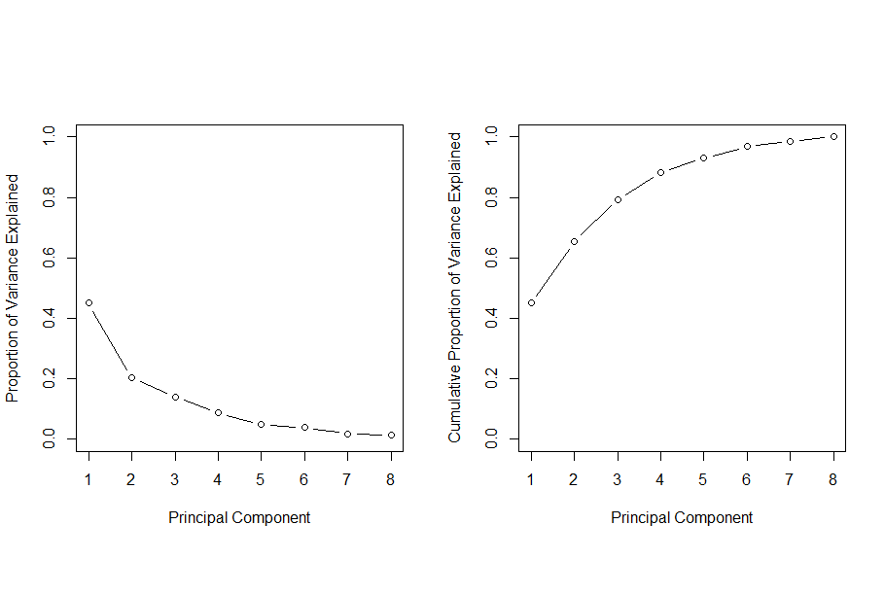

> cumsum(pve)

[1] 0.4498619 0.6538519 0.7928445 0.8812825 0.9293627 0.9677954 0.9858515 1.0000000

In the first graph there is a big drop from 1PC to 2PCs and a small drop from 6PCs to 7PCs. Also by looking at the Cumulative of PVE, we have 65% with 2PCs and 92% with 5PCs. So I would recommend to have more than 5PCs for this data set.

Population Income Illiteracy Life Exp Murder HS Grad Frost Area

PC1 0.2398436 -0.5669029 0.88720374 -0.7808560 0.8427885 -0.8056584 -0.6780384 -0.06333314

PC2 0.5248778 0.6629778 0.06766573 -0.1043129 0.3921173 0.3816642 -0.1961984 0.75067024

cumulative.PVE

PC1 0.4498619

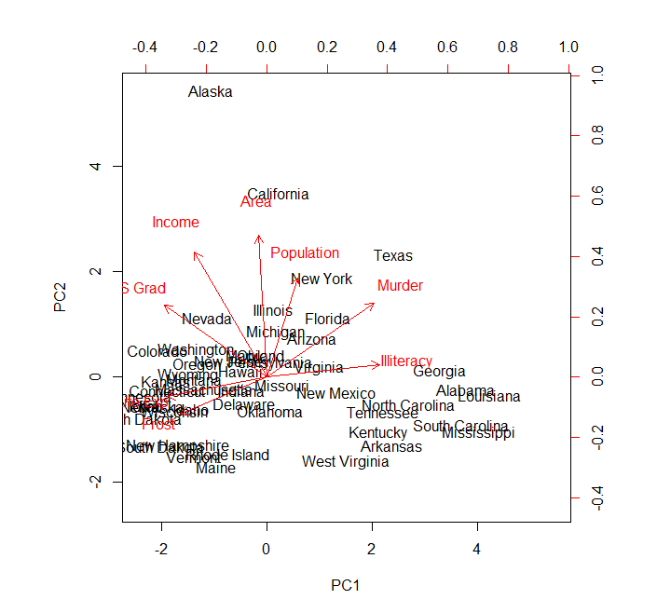PC2 0.6538519

With the figure, its clear that the two components are related to most of the states. This can also be seen with the cumulative percentage of the total variability explained. When you have the first two PCs cumulative.PVE = 0.6538519 and thus they were enough to explain more than half of the data. Most of the unexplained states are southern. Thus there is a southern component in the figure.

**Problem 2**

> signif(sort(train.latent.sem[, 1], decreasing = TRUE)[1:30], 2)

theater music m theaters composers matinee opera

0.180 0.130 0.080 0.079 0.078 0.077 0.075

> signif(sort(train.latent.sem[, 1], decreasing = FALSE)[1:30], 2)

her she ms painting paintings mother cooper artists

-0.150 -0.140 -0.130 -0.110 -0.100 -0.092 -0.090 -0.086

> signif(sort(train.latent.sem[, 2], decreasing = TRUE)[1:30], 2)

she her theater said i ms mother cooper

0.240 0.240 0.200 0.170 0.120 0.110 0.110 0.110

> signif(sort(train.latent.sem[, 2], decreasing = FALSE)[1:30], 2)

patterns chinese feb chelsea computers diamond europeans

-0.065 -0.051 -0.046 -0.046 -0.046 -0.045 -0.044

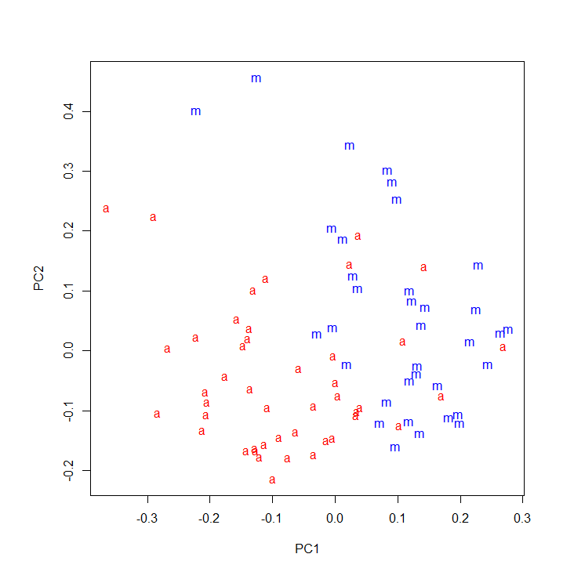With the 1st PC, words with positive projections are mostly associated with music, those with negative components with the visual arts and with the 2nd PC, the positive words are about art and the negative words are musical.

**Figure :** Projection of the Times stories on to the first two principal components. Music stories are marked with a blue “m”, art stories with a red “a”.

Total number of PCs is 80 and this is what we would expect since the training data set consist of 80 observations and 4432 predictors.

1. By looking at the above figure, we can see that almost all the words are separated into two groups, arts and music, with few been scattered around. So we can use the first two PCs for a good prediction.
2. estimate of the training error rate = 0.1625

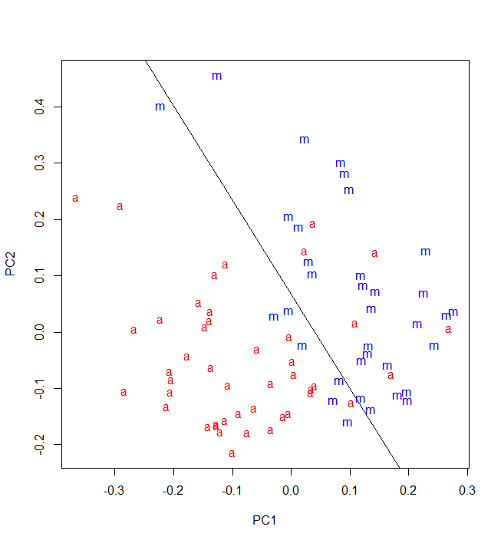

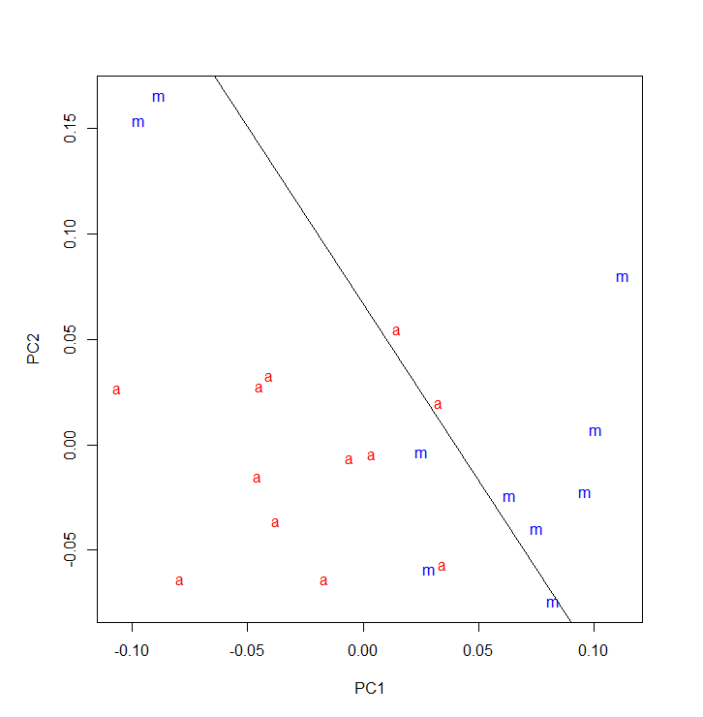With the glm fit, we were able give a decision boundary for the separation of the words into arts and music. Above graph shows this linear boundary and most of the words can be identify as arts or music with an error rate of 0.1625.

test.predicted.classes

art music

art 10 2

music 5 5

test error rate = (5+2)/22 = 0.3181818

class specific error rates

art = 2/12 = 0.1666667

music = 5/10 = 0.5

Figure shows how the 22 words in the test data set is scattered around and how the decision boundary from the glm fit is able to classify them.

1. We can increase the number of PCs considered for the glm fit and check the test error rate with the test data set so than we can pick M as the number of PCs that give the minimum test error rate. PCR method is used when the respond variable is qualitative. Thus its best to use PCA instead of PCR.

**Problem 3**

1. 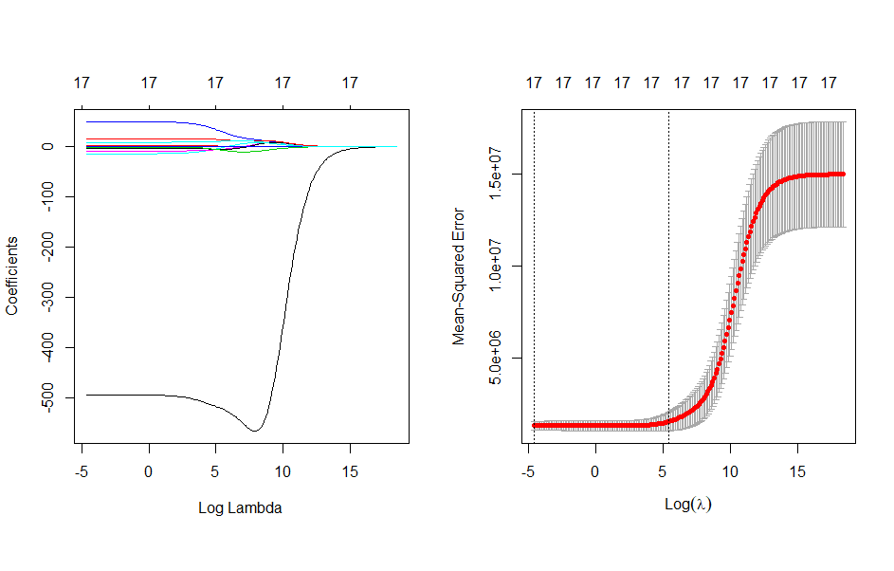Test error = 1276986
2. Optimal $λ$ = 0.01

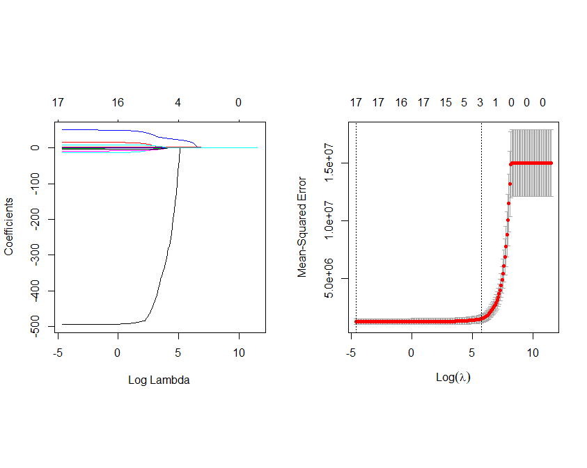

Test error = 1277006

1. Optimal $λ$ = 0.01

Test error = 1277099

> MSEP(pcr.fit)

(Intercept) 1 comps 2 comps 3 comps 4 comps 5 comps 6 comps 7 comps 8 comps 9 comps

CV 1.5e+07 14744421 4123358 4157777 2883584 2506292 2510774 2492036 2376917 2245553

adjCV 1.5e+07 14744466 4123261 4157770 2879623 2505933 2510639 2492027 2376694 2245437

10 comps 11 comps 12 comps 13 comps 14 comps 15 comps 16 comps 17 comps

CV 2237022 2251874 2251604 2267449 2267624 2067302 1357315 1276987

adjCV 2236914 2251762 2251488 2267334 2267512 2066763 1357131 1276825

17PCs gives them minimum MSEP. So the test error = 1276987

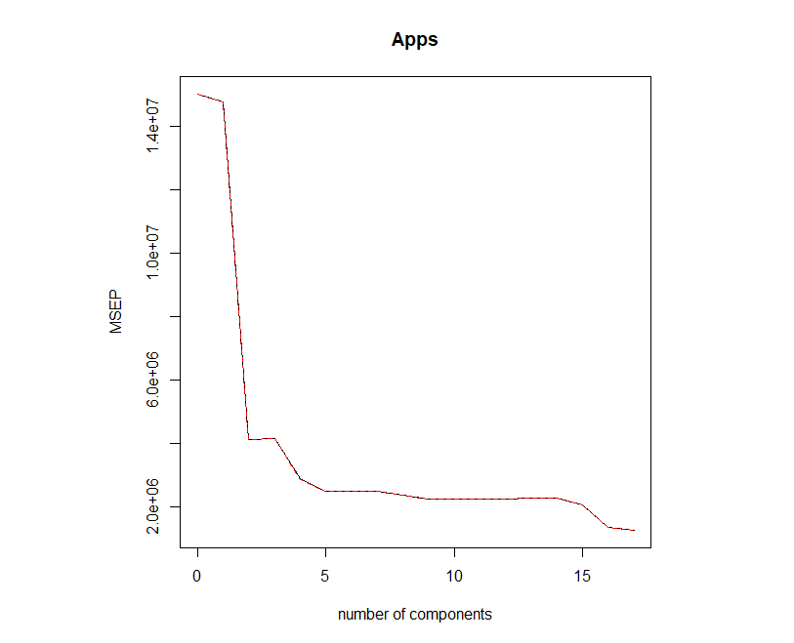

> MSEP(pls.fit)

(Intercept) 1 comps 2 comps 3 comps 4 comps 5 comps 6 comps 7 comps 8 comps 9 comps

CV 1.5e+07 3418008 2414639 2049701 1806343 1371151 1325548 1301942 1297801 1283053

adjCV 1.5e+07 3417887 2414598 2049563 1805870 1370529 1325245 1301788 1297869 1282936

10 comps 11 comps 12 comps 13 comps 14 comps 15 comps 16 comps 17 comps

CV 1282432 1280546 1279732 1278057 1277875 1277232 1276966 1276987

adjCV 1282273 1280398 1279576 1277894 1277712 1277070 1276804 1276825

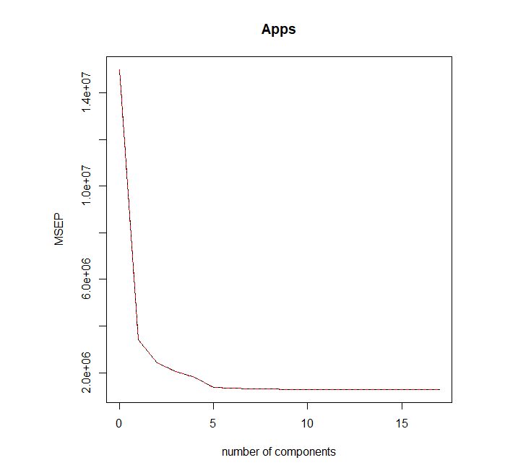16PCs gives them minimum MSEP. So the test error = 1276966

|  |  |  |  |  |  |
| --- | --- | --- | --- | --- | --- |
|  | Linear model | Ridge | Lasso | PCR | PLS |
| Test error (MSEP) | 1276986 | 1277006 | 1277099 | 1276987 | 1276966 |

Although all the models gives approximately closer test errors, lowest test error gives from PLS model.

# Problem 1

head(state.x77)

str(state.x77)

# Extract the names of states

states <- row.names(state.x77)

# part a)

summary(state.x77)

chart.Correlation(state.x77) #matrix of scatterplot and correlation after transformation

# part b)

# Look at mean and sd

apply(state.x77, 2, mean)

apply(state.x77, 2, sd)

# part c)

# Perform PCA

pca <- prcomp(state.x77, center = T, scale = T)

names(pca)

# Get the loading matrix

pca$rotation

# Get the score matrix

dim(pca$x)

head(pca$x)

# Check the covariance matrix of the scores

round(cov(pca$x), 4)

# Display a biplot the results (shows both pc scores and loading vectors)

pca$rotation

biplot(pca, scale=0)

# Display the biplot after changing the signs of loadings and scores

pca$rotation <- -pca$rotation

pca$x <- -pca$x

pca$rotation

biplot(pca, scale=0)

# Compute the proportion of variance explained (PVE)

pc.var <- pca$sdev^2

pve <- pc.var/sum(pc.var)

pve

cumsum(pve)

#Correlations

rbind(PC1 = c(pca$rotation[,1]*pca$sdev[1], cumalative.PVE = cumsum(pve)[1]),

PC2 = c(pca$rotation[,2]*pca$sdev[2], cumalative.PVE = cumsum(pve)[2]))

par(mfrow=c(1,2))

# Scree plot

plot(pve, xlab = "Principal Component", ylab = "Proportion of Variance Explained", ylim = c(0,1), type = 'b')

# Plot of cumulative PVE

plot(cumsum(pve), xlab = "Principal Component", ylab = "Cumulative Proportion of Variance Explained", ylim = c(0,1), type = 'b')

par(mfrow=c(1,1))

#Correlations

rbind(PC1 = c(pca$rotation[,1]*pca$sdev[1], cumalative.PVE = cumsum(pve)[1]),

PC2 = c(pca$rotation[,2]*pca$sdev[2], cumalative.PVE = cumsum(pve)[2]))

# problem 2

train.data <- read.csv("nyt.train.csv", header = T)

test.data <- read.csv("nyt.test.csv", header = T)

train.pca <- prcomp(train.data[, -1])

# We need to omit the first column because it contains categorical variables, and PCA doesn't apply to them.

train.latent.sem <- train.pca$rotation

signif(sort(train.latent.sem[, 1], decreasing = TRUE)[1:30], 2)

# theater music m theaters composers matinee opera

# 0.180 0.130 0.080 0.079 0.078 0.077 0.075

# sunday musical jersey p orchestra band committee

# 0.067 0.065 0.064 0.064 0.062 0.061 0.060

# performance performances east organ dance hour program

# 0.059 0.056 0.056 0.053 0.052 0.051 0.051

# events yesterday will recitals ballet purchase X.d

# 0.050 0.049 0.049 0.048 0.048 0.048 0.047

# guitarist calif

# 0.045 0.044

signif(sort(train.latent.sem[, 1], decreasing = FALSE)[1:30], 2)

# her she ms painting paintings mother cooper artists

# -0.150 -0.140 -0.130 -0.110 -0.100 -0.092 -0.090 -0.086

# white images i said process sculpture picasso gagosian

# -0.078 -0.077 -0.071 -0.070 -0.070 -0.070 -0.068 -0.065

# art my nature image color sculptures work red

# -0.064 -0.064 -0.064 -0.061 -0.061 -0.059 -0.059 -0.058

# artist rothko paint photographs paper figure

# -0.056 -0.055 -0.055 -0.055 -0.054 -0.054

signif(sort(train.latent.sem[, 2], decreasing = TRUE)[1:30], 2)

# she her theater said i ms mother cooper

# 0.240 0.240 0.200 0.170 0.120 0.110 0.110 0.110

# says opera my hour id im production was

# 0.089 0.084 0.084 0.082 0.081 0.079 0.075 0.075

# mrs play sir broadway awards you national garde

# 0.074 0.074 0.071 0.070 0.066 0.066 0.065 0.063

# me season jonathan week baby networks

# 0.062 0.062 0.062 0.060 0.059 0.059

signif(sort(train.latent.sem[, 2], decreasing = FALSE)[1:30], 2)

# patterns chinese feb chelsea computers diamond europeans

# -0.065 -0.051 -0.046 -0.046 -0.046 -0.045 -0.044

# gallery museum art heads white stone views

# -0.042 -0.041 -0.040 -0.039 -0.039 -0.039 -0.039

# painted recalling soho artists pills statue newman

# -0.039 -0.039 -0.039 -0.038 -0.037 -0.037 -0.037

# computer compositions grid landscapes spatial images wood

# -0.037 -0.037 -0.037 -0.037 -0.037 -0.036 -0.035

# technology personal

# -0.035 -0.035

plot(train.pca$x[, 1:2],

pch = ifelse(train.data[, "class.labels"] == "music", "m", "a"),

col = ifelse(train.data[, "class.labels"] == "music", "blue","red"))

# part c)

train.set <- data.frame(class.labels=train.data$class.labels,

CP1 = train.pca$x[, 1],

CP2 = train.pca$x[, 2])

predictors <- train.pca$x[, 1:2]

lm.fit <- glm(class.labels ~ CP1 + CP2, data = train.set, family = "binomial")

lm.pred <- predict(lm.fit, train.set, type = 'response')

predicted.classes <- as.factor(ifelse(lm.pred < 0.5, 'art', 'music'))

mean(train.data$class.labels != predicted.classes) # training error

# [1] 0.1625

slope <- coef(lm.fit)[2]/(-coef(lm.fit)[3])

intercept <- coef(lm.fit)[1]/(-coef(lm.fit)[3])

abline(intercept , slope)

# part d)

pca.scores <- predict(train.pca, test.data)[,1:2]

test.set <- cbind.data.frame(class.labels = test.data$class.labels,

CP1 = pca.scores[, 1],

CP2 = pca.scores[, 2])

plot(pca.scores[, 1:2],

pch = ifelse(test.data[, "class.labels"] == "music", "m", "a"),

col = ifelse(test.data[, "class.labels"] == "music", "blue","red"))

test.lm.pred <- predict(lm.fit, test.set , type = 'response')

test.predicted.classes <- as.factor(ifelse(test.lm.pred < 0.5, 'art', 'music'))

mean(test.data$class.labels != test.predicted.classes) # test error

# [1] 0.3181818

abline(intercept , slope)

# confusion matrix for test and training data

table(test.data$class.labels, test.predicted.classes)

# problem 3

library(caret) # for cross-validation

library(ISLR)

library(glmnet) # for ridge and lasso

library(pls) # for pcr and pls

train.data <- College

str(train.data)

attach(train.data)

# part a)

lm.fit <- train(Apps ~ .,

method = "lm",

data = train.data,

trControl = trainControl(method = "LOOCV"))

print(lm.fit)

# Resampling results:

#

# RMSE Rsquared MAE

# 1130.038 0.91468 630.0335

1130.038^2 # = 1276986

lm.pred <- predict(lm.fit, train)

mean((Apps - lm.pred)^2) # training error

# [1] 1059279

# part b)

# Create response vector and the design matrix (without the first column of 1s)

y <- Apps

x <- model.matrix(Apps ~ ., train.data)[, -1]

grid <- 10^seq(8, -2, length = 200)

# Fit ridge regression for each lambda on the grid

ridge.out <- glmnet(x, y, alpha = 0, lambda = grid)

plot(ridge.out, xvar = "lambda")

# leave one out cross-validation

set.seed(1)

ridge.cv.out <- cv.glmnet(x, y, alpha = 0, lambda = grid, nfolds = dim(train.data)[1])

plot(ridge.cv.out)

print(ridge.cv.out)

# Measure: Mean-Squared Error

#

# Lambda Measure SE Nonzero

# min 0.01 1277006 258548 17

# 1se 235.43 1516697 508117 17

# Find the best value of lambda

ridge.bestlam <- ridge.cv.out$lambda.min

# [1] 0.01

# log(ridge.bestlam) = -4.60517

coef.ridge <- predict(ridge.out, type = "coefficients", s = ridge.bestlam)

# 1

# (Intercept) -445.26830402

# PrivateYes -494.15980608

# Accept 1.58570739

# Enroll -0.88022903

# Top10perc 49.92174051

# Top25perc -14.23153321

# F.Undergrad 0.05734870

# P.Undergrad 0.04444658

# Outstate -0.08586349

# Room.Board 0.15104313

# Books 0.02090569

# Personal 0.03109799

# PhD -8.67805769

# Terminal -3.33091855

# S.F.Ratio 15.38992988

# perc.alumni 0.17691111

# Expend 0.07789878

# Grad.Rate 8.66799704

ridge.pred <- predict(ridge.out, s = ridge.bestlam, newx = x, type='response')

train.error.ridge <- mean((ridge.pred - y)^2) # training error

# [1] 1059279

# part c)

grid <- 10^seq(5, -2, length = 200)

# Fit lasso regression for each lambda on the grid

lasso.out <- glmnet(x, y, alpha = 1, lambda = grid)

plot(lasso.out, xvar = "lambda")

# leave one out cross-validation

set.seed(1)

lasso.cv.out <- cv.glmnet(x, y, alpha = 1, lambda = grid, nfolds = dim(train.data)[1])

plot(lasso.cv.out)

print(lasso.cv.out)

# Measure: Mean-Squared Error

#

# Lambda Measure SE Nonzero

# min 0.01 1277099 258652 17

# 1se 318.1 1524047 355598 3

# Find the best value of lambda

lasso.bestlam <- lasso.cv.out$lambda.min

# [1] 0.01

# log(lasso.bestlam) = -4.60517

coef.lasso <- predict(lasso.out, type = "coefficients", s = lasso.bestlam)

# 1

# (Intercept) -445.26830402

# PrivateYes -494.15980608

# Accept 1.58570739

# Enroll -0.88022903

# Top10perc 49.92174051

# Top25perc -14.23153321

# F.Undergrad 0.05734870

# P.Undergrad 0.04444658

# Outstate -0.08586349

# Room.Board 0.15104313

# Books 0.02090569

# Personal 0.03109799

# PhD -8.67805769

# Terminal -3.33091855

# S.F.Ratio 15.38992988

# perc.alumni 0.17691111

# Expend 0.07789878

# Grad.Rate 8.66799704

lasso.pred <- predict(lasso.out, s = lasso.bestlam, newx = x, type='response')

train.error.lasso <- mean((lasso.pred - y)^2) # training error

# [1] 1059279

# part d)

pcr.fit <- pcr(Apps~., data=train.data, scale=T, validation="LOO")

# Scree plot

validationplot(pcr.fit, val.type="MSEP")

MSEP(pcr.fit)

# (Intercept) 1 comps 2 comps 3 comps 4 comps 5 comps 6 comps 7 comps 8 comps 9 comps 10 comps

# CV 1.5e+07 14744421 4123358 4157777 2883584 2506292 2510774 2492036 2376917 2245553 2237022

# adjCV 1.5e+07 14744466 4123261 4157770 2879623 2505933 2510639 2492027 2376694 2245437 2236914

# 11 comps 12 comps 13 comps 14 comps 15 comps 16 comps 17 comps

# CV 2251874 2251604 2267449 2267624 2067302 1357315 1276987

# adjCV 2251762 2251488 2267334 2267512 2066763 1357131 1276825

pcr.pred <- predict(pcr.fit, train.data, ncomp=which.min(MSEP(pcr.fit)$val[1,1,]) - 1)

mean((Apps - pcr.pred)^2) # training error

# [1] 1059279

# part e)

pls.fit <- plsr(Apps~., data=train.data, scale=T, validation="LOO")

# Scree plot

validationplot(pls.fit, val.type="MSEP")

MSEP(pls.fit)

# (Intercept) 1 comps 2 comps 3 comps 4 comps 5 comps 6 comps 7 comps 8 comps 9 comps 10 comps

# CV 1.5e+07 3418008 2414639 2049701 1806343 1371151 1325548 1301942 1297801 1283053 1282432

# adjCV 1.5e+07 3417887 2414598 2049563 1805870 1370529 1325245 1301788 1297869 1282936 1282273

# 11 comps 12 comps 13 comps 14 comps 15 comps 16 comps 17 comps

# CV 1280546 1279732 1278057 1277875 1277232 1276966 1276987

# adjCV 1280398 1279576 1277894 1277712 1277070 1276804 1276825

pls.pred <- predict(pls.fit, train.data, ncomp=which.min(MSEP(pls.fit)$val[1,1,]) - 1)

mean((Apps - pls.pred)^2) # training error

# [1] 1059279